**Install Apache Maven on Linux (CentOS/RedHat/Debian)**

**Apache Maven** is a software project management and comprehension tool. Maven can manage a project’s build, reporting, and documentation from a central piece of information.   
  
In this tutorial, we will learn to install Apache Maven on Linux systems.  
  
**Install JAVA**  
  
First, install java according to your Linux distribution  
 [Install Java for Debian/Ubuntu based system](http://www.serverkaka.com/2017/10/how-to-install-java-8-on-ubuntu.html)  
  
[Install Java for CentOS/RedHat based system](http://www.serverkaka.com/2018/01/install-java-8-in-centosredhat.html)

**Install Apache Maven**  
  
After installing Java on your system. Download Apache maven using the following command

|  |
| --- |
| # cd /usr/local  # wget http://www-eu.apache.org/dist/maven/maven-3/3.5.2/binaries/apache-maven-3.5.2-bin.tar.gz |

Extract the downloaded package

|  |
| --- |
| # sudo tar xzf apache-maven-3.5.2-bin.tar.gz |

Create a symbolic link to the maven executable

|  |
| --- |
| # sudo ln -s apache-maven-3.5.2  maven |

Remove the downloaded archive file

|  |
| --- |
| # rm -f /usr/local/apache-maven-3.5.2-bin.tar.gz |

**Setup Maven Environment Variables**

Now set the environments variables by creating new file /etc/profile.d/maven.sh

|  |
| --- |
| # sudo vim /etc/profile.d/maven.sh |

add following content in to the file.

|  |
| --- |
| export M2_HOME=/usr/local/maven  export PATH=${M2_HOME}/bin:${PATH} |

Now load the environment variables in the current shell using the following command.

|  |
| --- |
| # source /etc/profile.d/maven.sh |

**Check Maven Version**

That’s it, Maven is installed and Use the following command to check the version of Maven.

|  |
| --- |
| # mvn -version |

[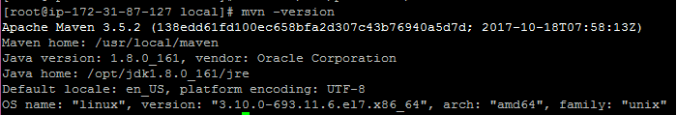](https://1.bp.blogspot.com/-s6gVtJXggac/WoE81pXwbnI/AAAAAAAAHTI/LOMnlpzB7aUZacPpqCGiVImoXyu9HrCZgCLcBGAs/s1600/maven.PNG)